FACULTY EVALUATION
Programme Name: Social Entrepreneurship Program (SEP)- START MASTERCLASS Uganda (26th January 2026 - 30th January 2026)
Session: Reflection of SEP Learning
Faculty Name: Dr. Tom Buringuriza
No. of Respondents: 13
No. of Participants: 13
Evaluation Parameter | (%) Individual Score | (%) Programme Average
Punctuality (Commencement and Completion of Sessions) | 91 | 88
How well do you understand the core concepts presented? | 85 | 83
Rate your confidence in applying the new skills learnt | 83 | 78
Degree of Faculty preparedness for the sessions | 85 | 91
Content and methodology of the program | 86 | 87
Quality of class and group discussions | 86 | 82
The information presented in the course is relevant to my work (ministry) | 91 | 91
Average scores | 87 | 86

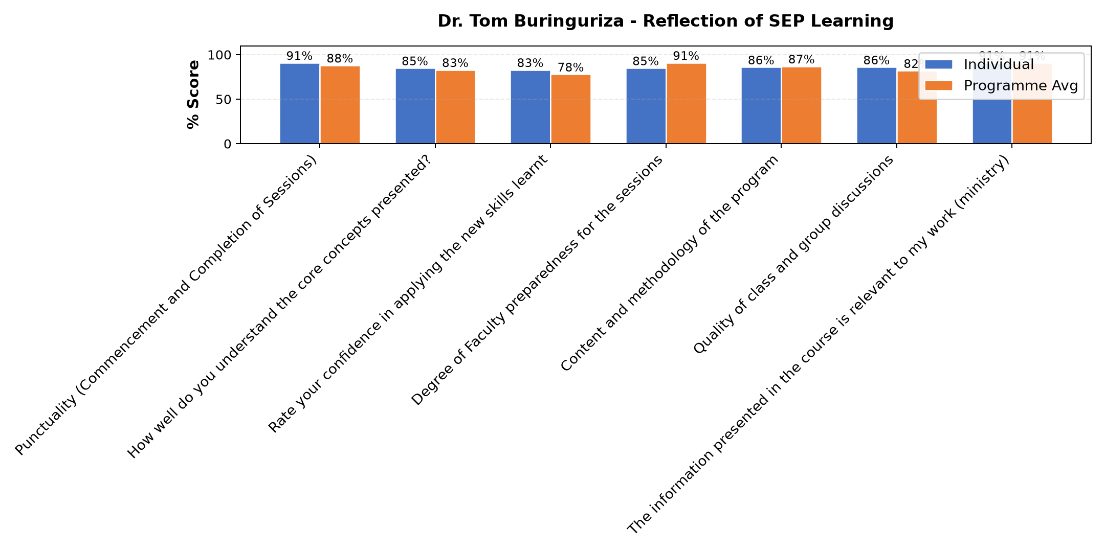

Comments & Feedback
- • Not performing my duties with in the enterprise and to some extent inadequate resource
- • Organizational structure, as was selected to be a project manager but I could not contrate since the Superiors of the congregation gave me a chance to go back to school so balancing the two became a problem
- • Organizational structure issues, i was requested by the superior of the congregation so balancing the role of the project manager and being a student at the same time being student became a challenge to me
- • Language barrier
- • Too much work in ministry, however with proper planning it can make work easier.
- • Being far from the social enterprice.
- • limited resource personnel as we make movements to the villages
- • Maybe if I get a transfer and I don't find the same enterprise where I am assigned.
- • Went back for further studies
- • Skills and experience
- • Net work and internet connections
- • Lacked enough time since I was anged with studies
SUBMITTED THROUGH:
SBS Evaluation Automation System

